# Instalación de docker

* Actualizar servidor linux

$ sudo apt-get update

* Instalar paquetes

$ sudo apt-get install \

ca-certificates \

curl \

gnupg \

lsb-release

* Instalar Docker

$ sudo apt-get update

$ sudo apt-get install docker-ce docker-ce-cli containerd.io

* Evidencia docker versión

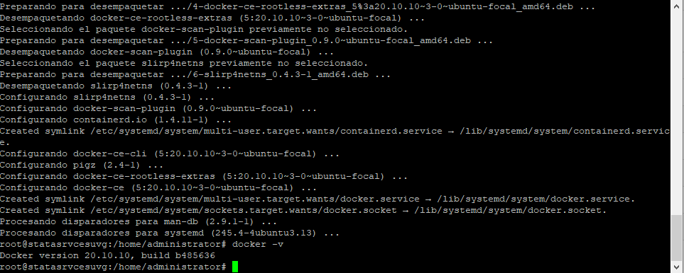

# Comandos

* docker run hello-world

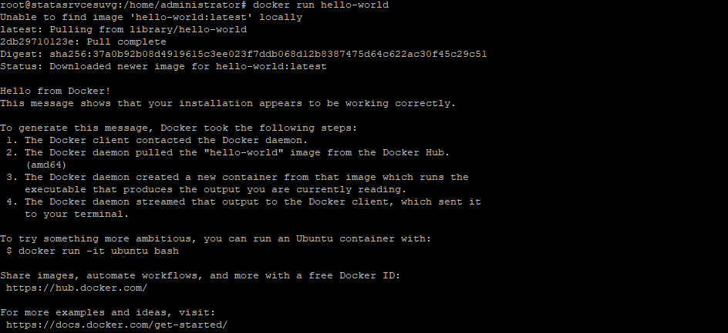

* docker pull busybox

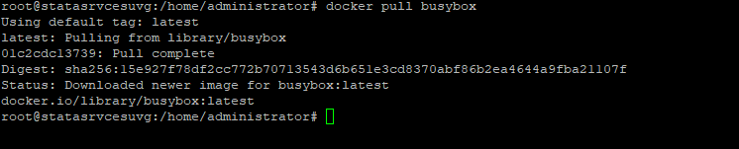

* docker images



* docker run busybox echo - "Hola mundo"
* docker ps



* docker ps –a



* docker run -it busybox sh

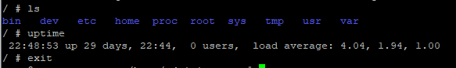

* docker rm b210d3f9c553

# Docker Python

## Instalar docker jupyter

* docker pull jupyter/base-notebook

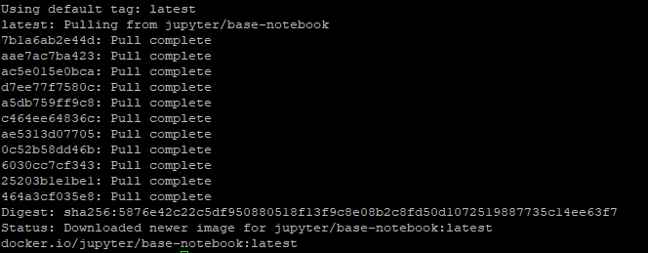

## Mapeo de puertos

* docker run -p 8888:8888 jupyter/base-notebook

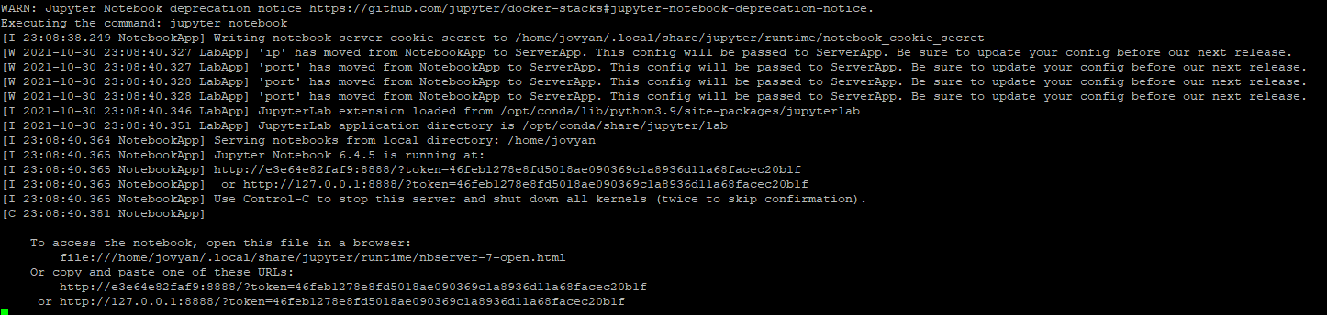

## Crear una red virtual

* docker network create --driver bridge my_test_network

## Ejecutar contenedor de mysql

* docker run -it --network my_test_network -e "MYSQL_ROOT_PASSWORD=root123" -e "MYSQL_DATABASE=test" -e "MYSQL_USER=test" -e "MYSQL_PASSWORD=test123" mysql:5.7.35

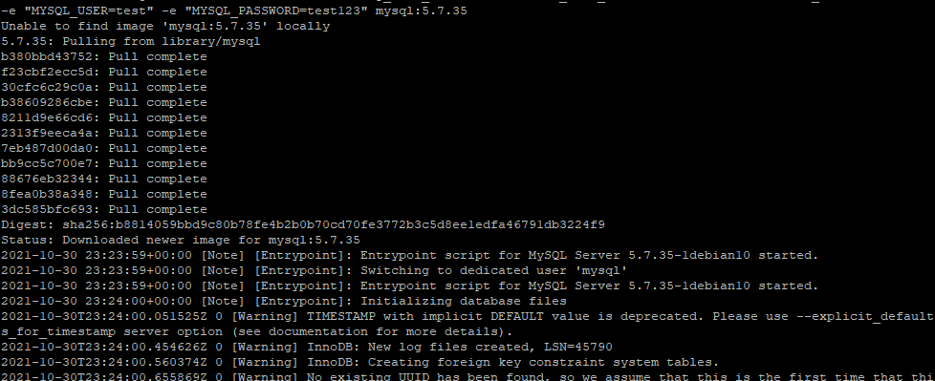

## Jupyter Run

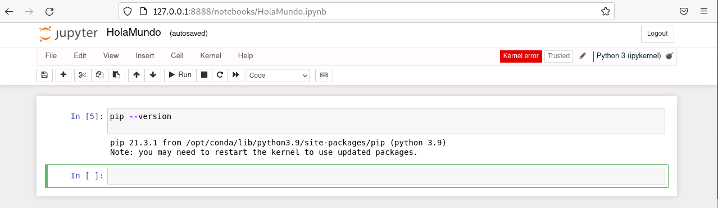

* Docker ps



## Install connector Mysql

pip install mysql-connector-python

pip install pandas

## Conexión a mysql from Python

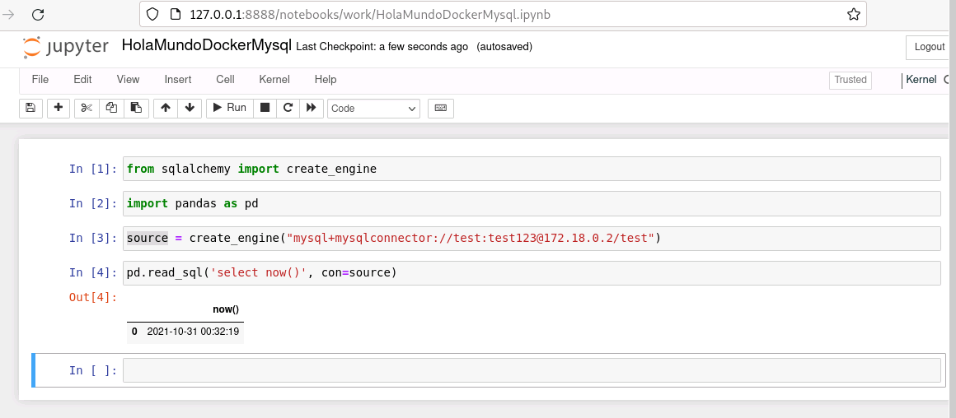

# Composer

## Instalar

* sudo curl -L "https://github.com/docker/compose/releases/download/1.29.2/docker-compose-$(uname -s)-$(uname -m)" -o /usr/local/bin/docker-compose
* sudo chmod +x /usr/local/bin/docker-compose
* docker-compose –version



version: '3.7'

services:

mydb:

image: mysql:5.7.35

volumes:

- db_data:/var/lib/mysql

restart: always

ports:

- 3306:3306

environment:

MYSQL_ROOT_PASSWORD: test123

MYSQL_DATABASE: test

MYSQL_USER: test

MYSQL_PASSWORD: test123

jupyter:

image: jupyter/base-notebook

ports:

- 8888:8888

volumes:

db_data: